Hammad Ahmad

[Hza5260@psu.edu](mailto:Hza5260@psu.edu)

CMPSC 457

FALL 2024

FINAL PROJECT

Project: Clone of Slenderman: The Eight Pages

Description: "Slenderman: The Eight Pages" is a first-person survival horror game where the player navigates a dark forest to collect eight scattered pages while avoiding the threat of Slenderman; a tall faceless humanoid who kills and causes camera distortions. The player is only equipped with a camera flashlight to search for the eight pages scattered throughout the forest.

Github: [SgtRocket786/Slender](https://github.com/SgtRocket786/Slender)

**2. Description of 2D/3D Models Used**

* Sourced Slenderman Model:  
  The Slenderman character model was sourced from the *User1Productions* collection (accessible via [YouTube Playlist](https://www.youtube.com/playlist?list=PLlcgaDpDEvw0t2lf6HXNowJjrK2x3-4TO)) and implemented as the main antagonist. It features basic rotation animations and dynamic teleportation logic to create a sense of fear and unpredictability.
* Map Features:  
  The map assets, including structures and environmental props, were sourced from the *User1Productions* collection (accessible via [YouTube Playlist](https://www.youtube.com/playlist?list=PLlcgaDpDEvw0t2lf6HXNowJjrK2x3-4TO)).
* Tree Models:  
  Trees and grass were sourced from the *Tree9 Realistic Tree 9 [Rainbow Tree]* package by *Pixel Games*. These realistic models provide dense and visually immersive foliage, adding to the forest's eerie ambiance.
* Street Lamps:  
  Lamps around the map were sourced from the *Street Lamps 2* package by *SpaceZeta*. These lamps act as static light sources, breaking up the darkness with their warm glow and adding visual landmarks for navigation.
* Stone Fence Barrier:  
  The *Stone Fence* asset was used to place a perimeter around the forest. The placement follows the edge of the playable area, creating a well-defined boundary while maintaining immersion. It is also used to indicate that the player trespassed into restricted territory by hopping the fence.

**3. Transformation Techniques Applied**

Transformations were applied dynamically throughout the game to create a suspenseful and immersive horror experience:

* Slenderman’s Rotation:  
  Slenderman dynamically rotates to face the player at all times using transformation logic. This ensures he remains a constant, menacing presence and keeps the player alert and unnerved.
* Slenderman’s Teleportation:  
  Slenderman teleports between locations based on proximity to the player and probabilistic AI decisions. This feature uses transformations to change his position within the environment, making his movements unpredictable and heightening the fear factor.
* Environmental Object Placement:  
  Trees, rocks, and props are strategically placed and scaled throughout the map using translation, rotation, and scaling transformations to provide an environment of a once frequently visited park now restricted to the public.

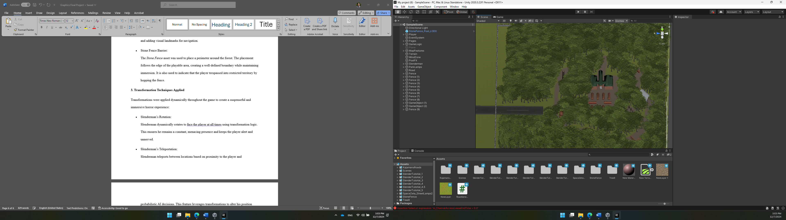

**4. Projection Techniques Used**

* Perspective First-Person Camera Projection:  
  The game uses a perspective projection camera set to a first-person view to immerse the player in the environment. This perspective enhances the horror atmosphere by limiting the player's field of view, making the game feel more intense and personal.
* HUD Integration:  
  A heads-up display (HUD) is implemented to display critical information, such as the page collection counter, ensuring the player remains aware of progress. The HUD dynamically updates as the player collects pages.
* 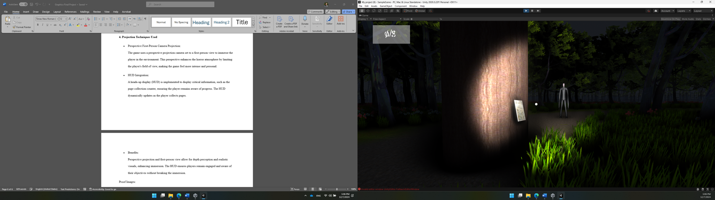Benefits:  
  Perspective projection and first-person view allow for depth perception and realistic visuals, enhancing immersion. The HUD ensures players remain engaged and aware of their objectives without breaking the immersion.

**5. Textures or Shading Applied**

* Page Textures:  
  Custom materials for the collectible pages were sourced and applied, ensuring they stand out while remaining thematically consistent. The shader setting used was Sprites: Diffuse to ensure that the contents of the pages were clearly visible and not invisible due to the player’s flashlight, nor were they visible enough to easily be seen.
* Lighting:
  + Directional Light: Simulates the faint moonlight of a dark night sky, creating an overall dark and eerie ambiance.
  + Spotlight (Flashlight): The player's flashlight is implemented as a spotlight, providing focused lighting that creates suspense by limiting visibility, creating dependence on light, and emphasizing shadows.
  + Point Lights (Street Lamps): Lamps implemented as point lights illuminate specific areas, breaking the darkness and acting as visual landmarks while enhancing the horror theme. The lights also look like Slenderman’s head in the distance, potentially scaring the player further.
* Terrain Painting:  
  The terrain was painted with grass and dirt path textures to create a natural forest environment. Grass covers most of the playable area, while dirt paths guide the player’s exploration.
* Post-Processing Effects:  
  Ambient Occlusion, Vignette, Bloom, and Grain effects were applied to the overall scene. These enhance the visual quality by adding realism, contrast, and subtle noise, further immersing the player in the horror setting. When Slenderman is dangerously close to the player, static emerges to warn and scare the player by further limiting visiblity and to indicate proximity to death. The static is a video applied to a flat cube attached to the player’s camera.
* Benefits:  
  The combination of these lighting techniques and post-effects enhances the horror atmosphere by simulating realistic lighting conditions, creating suspense through controlled visibility, and emphasizing contrast between light and shadow.

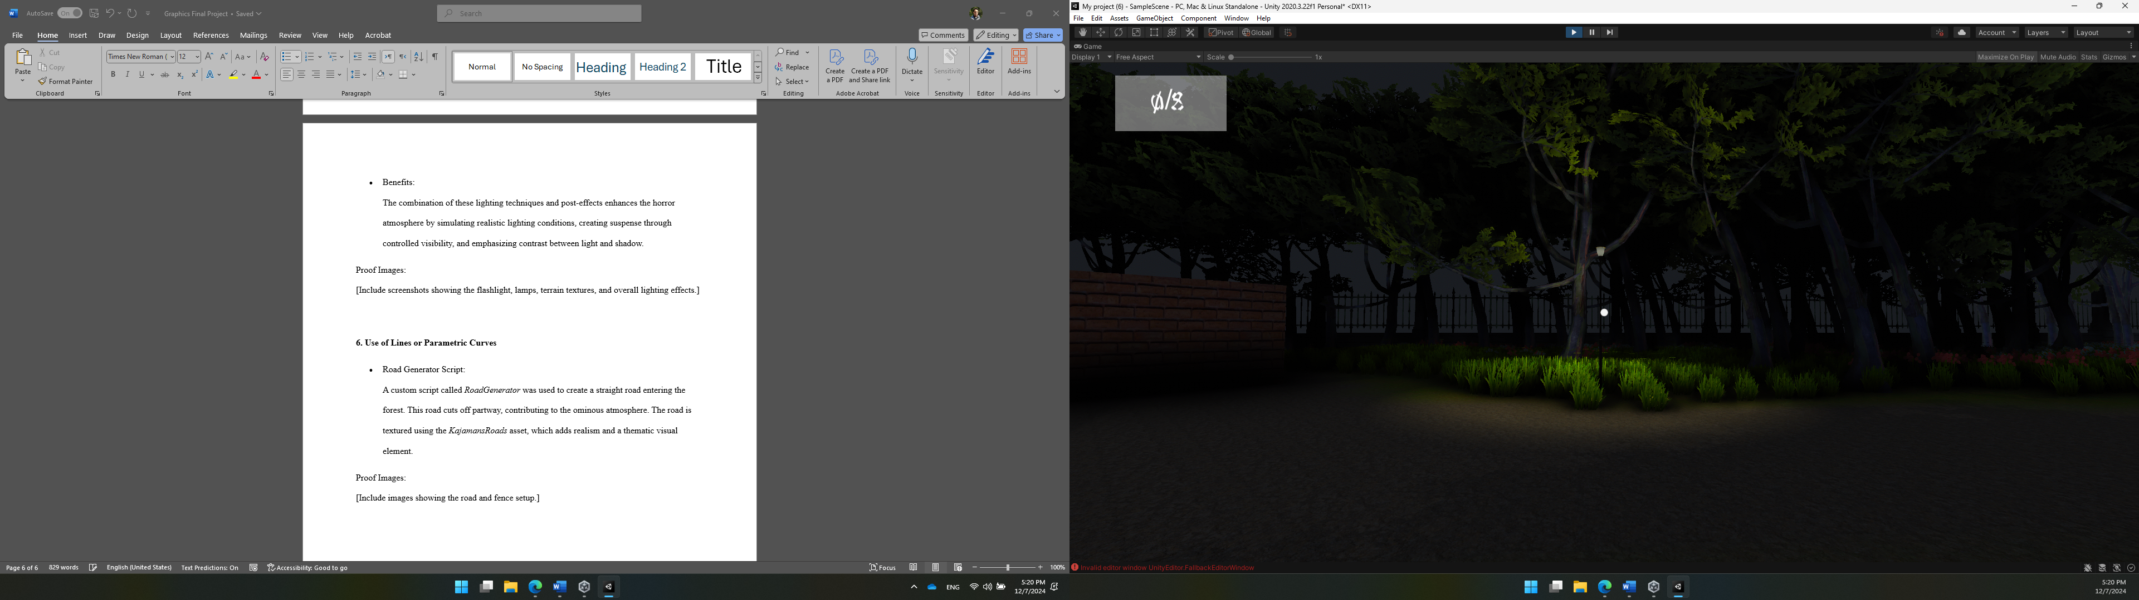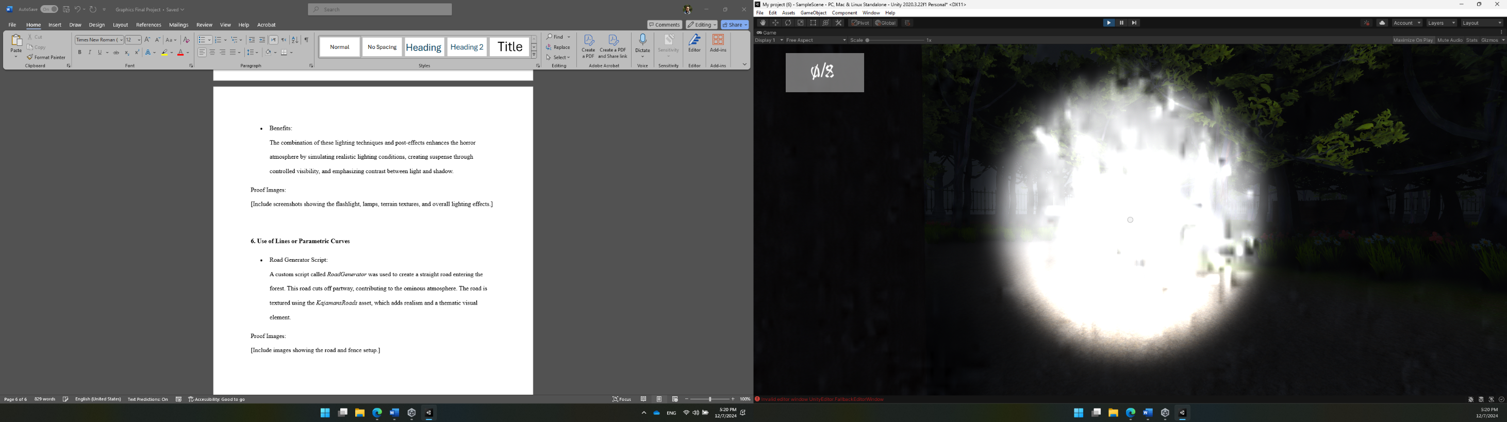

**6. Use of Lines or Parametric Curves**

* Road Generator Script:  
  A custom script called *RoadGenerator* was used to create a straight road entering the forest. This road cuts off partway, contributing to the ominous atmosphere by indicating that the road was not meant to be completed in the restricted forest.
* The road is textured using the *KajamansRoads* asset, which adds realism and a thematic visual element.

